EXP 7
Write a Servlet program to store a user's preferences (like theme or language) using cookies. Retrieve and display these preferences on subsequent visits. Write a Servlet program to store a user's preferences (like theme or language) using cookies. Retrieve and display these preferences on subsequent visits.

AIM
To create a Servlet-based web application that stores user preferences (such as theme or language) using cookies and retrieves them on subsequent visits.

ALGORITHM
- Start the application.
- Accept user preferences (theme/language) through a form.
- Create cookies for each preference.
- Set the cookie expiry time.
- Store cookies in the client’s browser.
- When the user revisits the application:
  - Read cookies from the request.
  - Check for stored preferences.
- If cookies are found: o Retrieve and display the stored preferences.
- If cookies are not found: o Display default values or ask the user to set preferences.
- Stop the application.

STEPS
- Design a user interface to collect preferences like theme and language.
- Configure a Servlet to handle form submission.
- Use cookies to store the user’s preferences in the browser.
- Set an appropriate expiry time for cookies.
- Send cookies along with the response to the client.
- On subsequent visits, retrieve cookies from the request object.
- Extract stored values (theme/language).
- Display the preferences to the user dynamically.
- Handle cases where cookies are absent by showing default settings.

Program:

Index.html:

<!-- index.html -->
<!DOCTYPE html>
<html lang="en">
<head>
<meta charset="UTF-8">
<meta name="viewport" content="width=device-width, initial-scale=1.0">
<title>Student Information Management System</title>

<style>
body{
margin:0;
font-family:Arial, sans-serif;
background:linear-gradient(135deg,#1565c0,#42a5f5,#00c6ff);
height:100vh;
display:flex;
justify-content:center;
align-items:center;
}

.container{
width:420px;
background:white;
padding:30px;
border-radius:15px;
box-shadow:0 10px 25px rgba(0,0,0,0.2);
}

h2{
text-align:center;
color:#1565c0;
margin-bottom:20px;
}

label{
font-weight:bold;
display:block;
margin-top:12px;
}

select{
width:100%;
padding:10px;
margin-top:8px;
border-radius:8px;
border:1px solid #ccc;
}

button{
width:100%;
margin-top:20px;
padding:12px;
background:#1565c0;
color:white;
border:none;
JA
border-radius:8px;
cursor:pointer;
font-size:16px;
}

button:hover{
background:#0d47a1;
}
</style>
</head>

<body>

<div class="container">
<h2>Student Preferences</h2>

<form action="PreferenceServlet" method="post">

<label>Select Theme</label>
<select name="theme">
<option>Light</option>
<option>Dark</option>
</select>

<label>Select Language</label>
<select name="language">
<option>English</option>
<option>Tamil</option>
</select>

<label>Select Dashboard Mode</label>
<select name="mode">
<option>Student</option>
<option>Admin</option>
</select>

<button type="submit">Save Preferences</button>

</form>
</div>

</body>
</html>

JAVA:

// PreferenceServlet.java

import java.io.*;
import javax.servlet.*;
import javax.servlet.http.*;
import javax.servlet.annotation.WebServlet;

@WebServlet("/PreferenceServlet")

public class PreferenceServlet extends HttpServlet {

public void doPost(HttpServletRequest req,
HttpServletResponse res)
throws IOException {

Cookie theme =
new Cookie("theme", req.getParameter("theme"));

Cookie language =
new Cookie("language", req.getParameter("language"));

Cookie mode =
new Cookie("mode", req.getParameter("mode"));

theme.setMaxAge(86400);
language.setMaxAge(86400);
mode.setMaxAge(86400);

res.addCookie(theme);
res.addCookie(language);
res.addCookie(mode);

res.setContentType("text/html");

PrintWriter out = res.getWriter();

out.println("<html><body style='font-family:Arial;background:#f4f7fc;text-align:center;padding-top:100px;'>");

out.println("<h2 style='color:#1565c0;'>Preferences Saved Successfully</h2>");

out.println("<a href='DisplayServlet'>View Dashboard</a>");

out.println("</body></html>");
}
}

// DisplayServlet.java

import java.io.*;
import javax.servlet.*;
import javax.servlet.http.*;
import javax.servlet.annotation.WebServlet;

@WebServlet("/DisplayServlet")

public class DisplayServlet extends HttpServlet {

public void doGet(HttpServletRequest req,
HttpServletResponse res)
throws IOException {

String theme="Light";
String language="English";
String mode="Student";

Cookie[] c = req.getCookies();

if(c != null){
for(Cookie x : c){

if(x.getName().equals("theme"))
theme = x.getValue();

if(x.getName().equals("language"))
language = x.getValue();

if(x.getName().equals("mode"))
mode = x.getValue();
}
}

res.setContentType("text/html");

PrintWriter out = res.getWriter();

out.println("<html><body style='font-family:Arial;background:#e3f2fd;'>");

out.println("<div style='width:500px;margin:80px auto;background:white;padding:25px;border-radius:15px;box-shadow:0 0 15px gray;text-align:center;'>");

out.println("<h2 style='color:#1565c0;'>Student Information Dashboard</h2>");

out.println("<p><b>Theme:</b> " + theme + "</p>");
out.println("<p><b>Language:</b> " + language + "</p>");
out.println("<p><b>Mode:</b> " + mode + "</p>");

if(language.equals("Tamil"))
out.println("<h3>வரவேற்கிறோம்</h3>");
else
out.println("<h3>Welcome Back</h3>");

out.println("<a href='index.html'>Change Preferences</a>");

out.println("</div></body></html>");
}
}

OUTPUT:

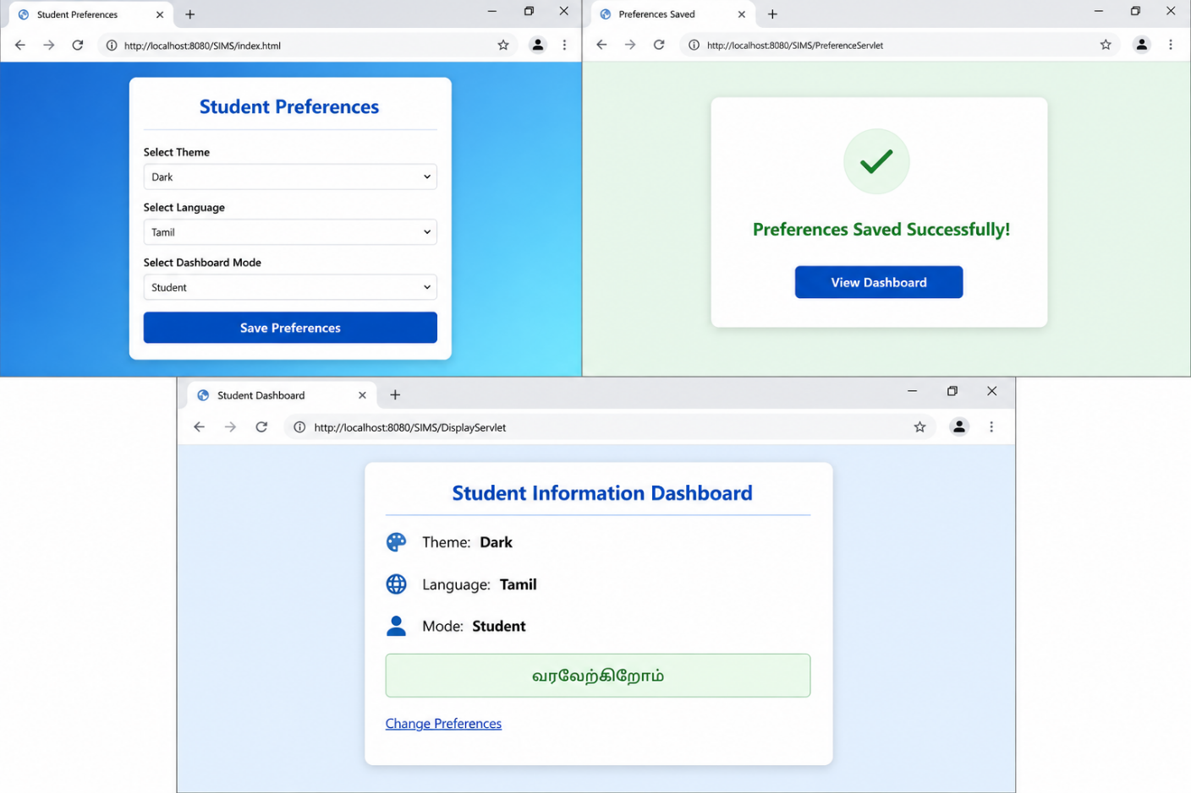

RESULT
The Servlet application successfully stores user preferences using cookies and retrieves them on subsequent visits, providing a personalized user experience.

